Michael Shalaby
CSD325 - Advanced Python
Bellevue University
Assignment 8.2

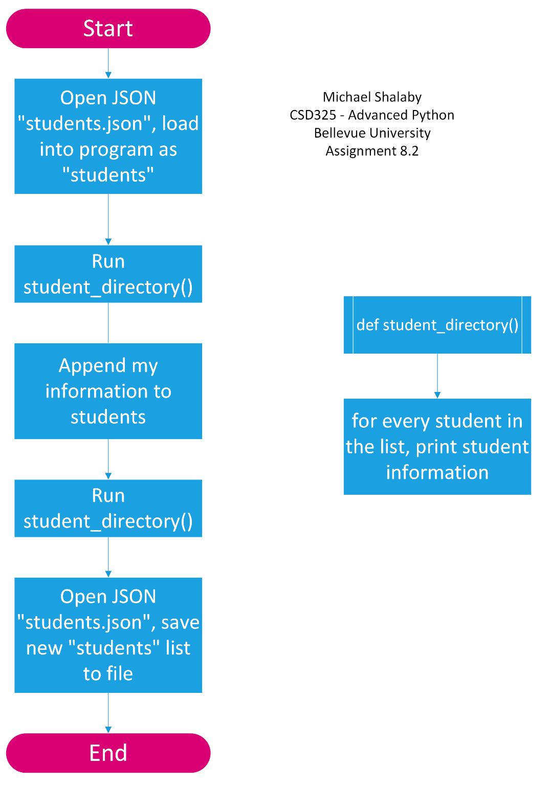

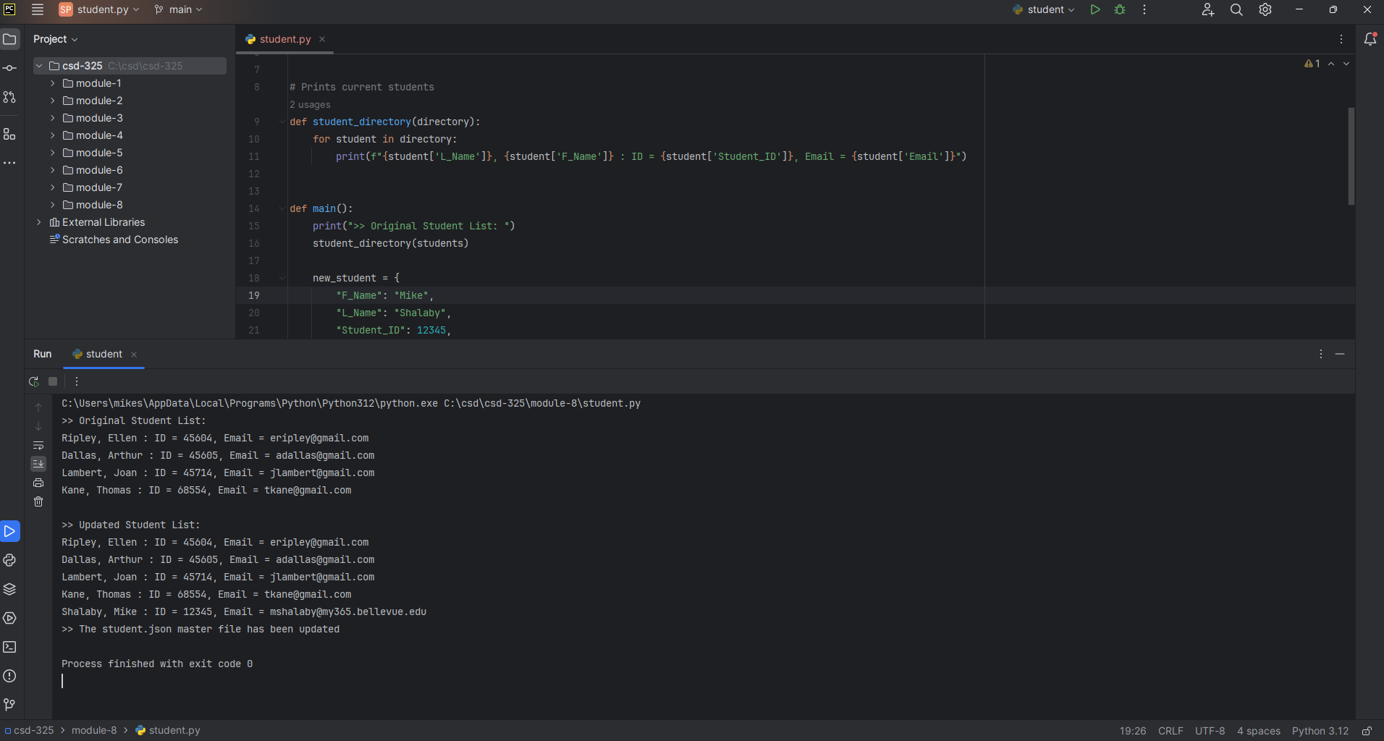

I did not get a Windows notification that the file was changed by an outside source, but it did change the file:
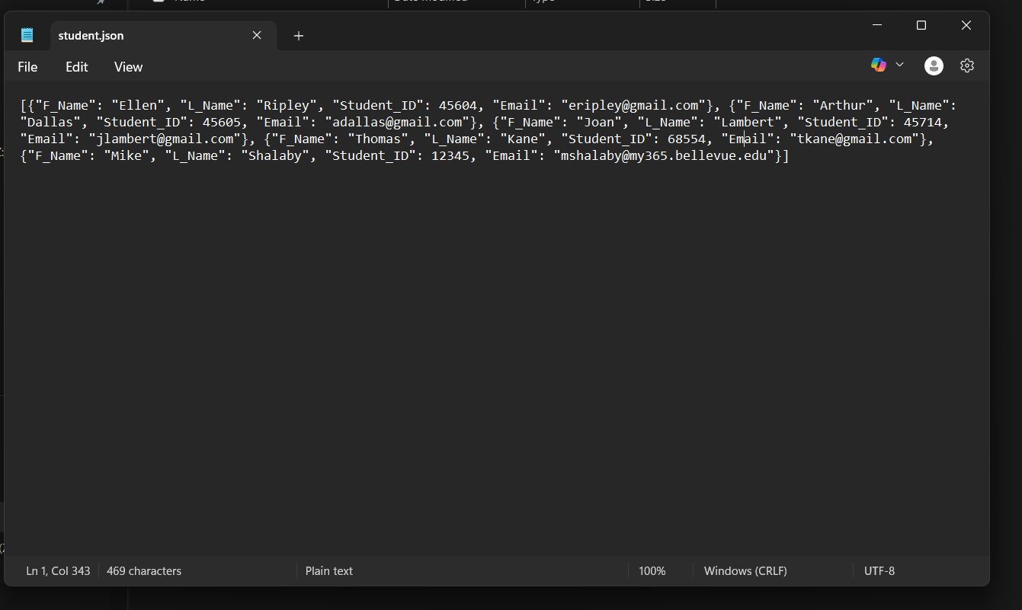
[{"F_Name": "Ellen", "L_Name": "Ripley", "Student_ID": 45604, "Email": "eripley@gmail.com"}, {"F_Name": "Arthur", "L_Name": "Dallas", "Student_ID": 45605, "Email": "adallas@gmail.com"}, {"F_Name": "Joan", "L_Name": "Lambert", "Student_ID": 45714, "Email": "jlambert@gmail.com"}, {"F_Name": "Thomas", "L_Name": "Kane", "Student_ID": 68554, "Email": "tkane@gmail.com"}, {"F_Name": "Mike", "L_Name": "Shalaby", "Student_ID": 12345, "Email": "mshalaby@my365.bellevue.edu"}]

